NO COST* (to you) ways to support
Da Vinci Charter Academy & Junior High School
via the Boosters.

<You can also find out how to make cash donations at the end of this handout>

You can help the Da Vinci Charter Academy Boosters help provide additional resources to both the Senior and Junior High Schools.

NO COST to you* (Merchant donates. You get to spend the full amount)
PROGRAM | Merchant Donation | Details
Amazon Smile | 0.5% | Browser (on computer): Smile.Amazon.com -or-  App: Find Settings in the main menu (☰). Tap on ‘AmazonSmile’ and follow the on-screen instructions  Must renew Smile on APP every 6 mo (N/A for Smile.Amazon.com on your computer).
Nugget Market | 1-4% | 1) Pick up a physical SCRIP card from Nugget (or Da Vinci)  2) Make an account at https://scrip.nuggetmarket.com/  3) Scan your card when you pay at Nugget checkout
ShopWithScrip | Up to14% (most 2-6%) | Browser (on computer): ShopWithScrip.com -or-  RaiseRight App  Enrollment Code: 2514L28417653  Over 750 Retailers.  *15 cent charge if you purchase from bank account vs 2.6% if you use a credit card  Depending on retailer, you either:  - Reload a plastic card (Safeway, ARCO, …), or  - Pay from Wallet (Buca di Beppo, …), or  - Transfer funds to merchant’s own app (Starbucks, …)  After you link to a bank account, I recommend trying it out with one retailer. We personally started with Safeway $150, with a 15 cent fee charged to bank account. We printed out a copy and presented it at checkout. In future will get plastic card and reload that.
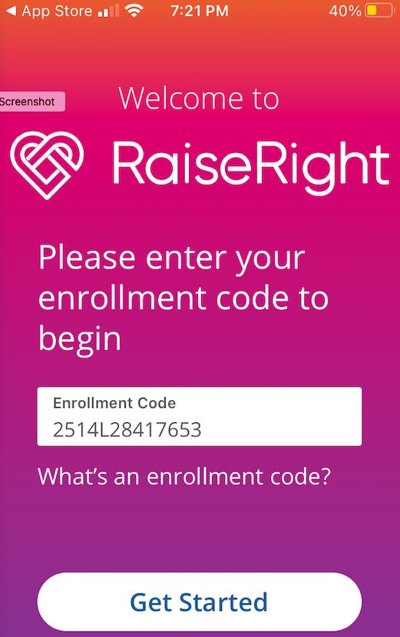

HOW THESE DONATIONS HELP
The Boosters has been able to provide additional financial support for:
Junior High Campus:
- PE equipment and supplies, music support, robotics supplies, scientific kits
- Signature events , Field trip, Teacher and staff appreciation
High School Campus:
- Signature events (1929 Night, WW1 Night)
- Teacher and staff appreciation

DIRECT FINANCIAL SUPPORT from you
IF YOU ARE ABLE TO DONATE CASH
For those of you who are in a position to help with direct cash donations, consider supporting the Boosters as part of this. Show your support for your schools!

The easiest way to make a “cash” donation is to do this is at the DaVinciBoosters.net website.
Click on the logo to donate via PayPal. 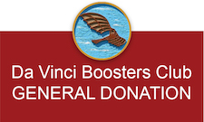

Da Vinci Boosters

Serving Da Vinci Charter Academy

